Microsoft Office

Word

IT & PC Notes- Dr. Nayna Porwal

Introduction

- Word processing is the manipulation of characters, words, text, numbers, sentences, and paragraphs in the document so that it is error- free and looks attractive.
- A word processor is an application software for word processing.
- The various Word processor packages that are being used are Word Perfect, Word Star, and Microsoft Word, etc.
- Microsoft Word has a wide variety of features that makes it one of the most popular and widely used applications. It produces professional documents quickly and efficiently.

Starting MS Office
  - To open MS Word, perform any one of the following steps :
    - Double-click the Microsoft Word icon located on the desktop.
    - Click start, point to All Programs, point to Microsoft Office and then select Microsoft Office Word .

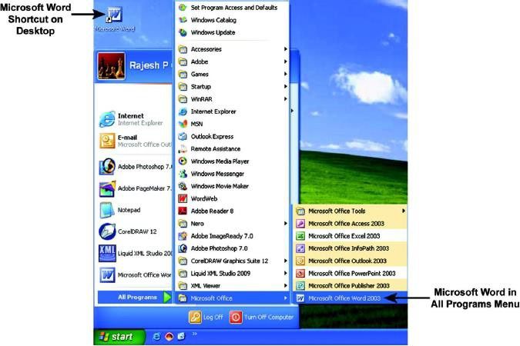

Starting MS Office Word (Contd.)

Microsoft Word Environment

  - When MS Word is opened, the main screen of the program appears. The main window of MS Word has several components as shown in the figure below:

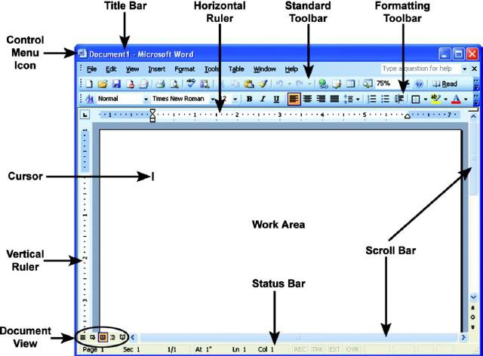

Starting MS Office Word (Contd.)

Getting Help

- Microsoft Office provides an exhaustive help system to provide assistance when you are experiencing difficulty using any Office application.

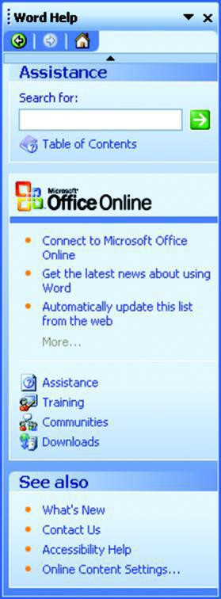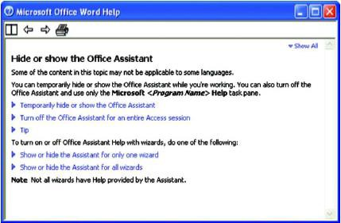

Working with Word Documents

Creating A New Document
- To open a new document, follow these steps:
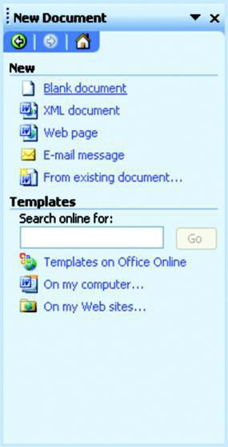
  - Select New from the File menu to display the New Document task pane.

  - Select Blank Document under the New section. Word opens a new document, which is sequentially numbered like Document1, Document2, and so on. Similarly, you can also create an XML document, a Web page, an E-mail message, and a document from the existing document by selecting appropriate options.

Working with Word Documents (Contd.)

Opening an Existing Document
    - To open an existing document, follow any of the steps given below:
      - Select Open from the File menu to display the Open dialog box. The Open dialog box allows you to specify the name of the desired file in the File name drop-down box. If the desired file is not in the current location, you can locate it by navigating through Look in drop-down box. Once the file is found, select the file and click the Open button.
      - A word document can also be opened by double-clicking the Word
file icon, placed on the specified location.

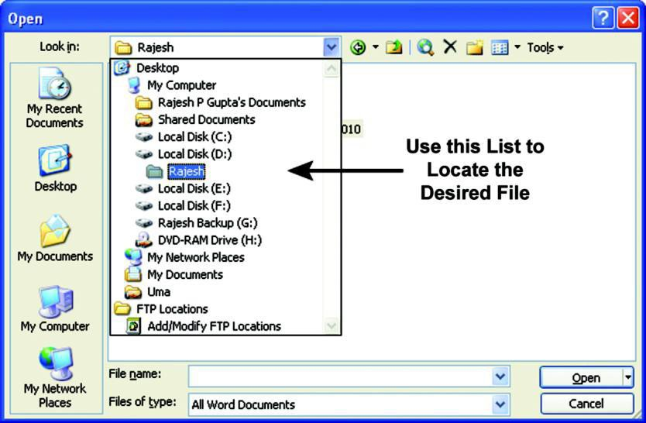

Working with Word Documents (Contd.)

Saving a Document
- To save the document, Microsoft Word provides two menu options, namely, Save and Save As.

- By default, Microsoft Word documents are saved with .DOC extension. Although it can also be saved in other file formats like
.TXT, .RTF, and .HTML.

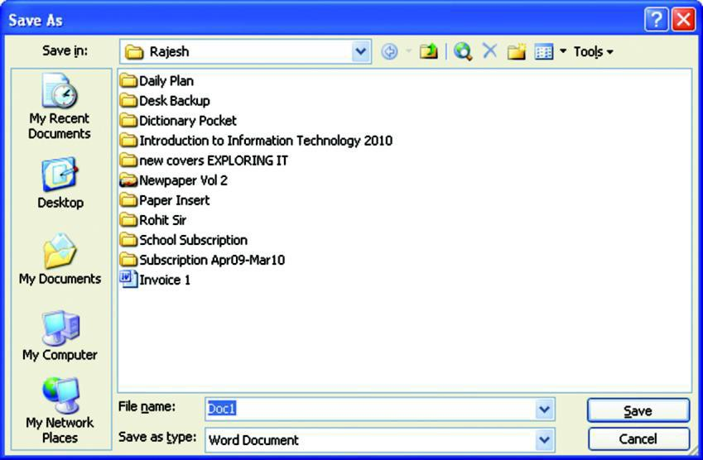

Working with Word Documents (Contd.)

Closing a Document and Exiting Microsoft Word
  - Select Close from File menu to close the document and select Exit from File menu to close the Word program.

  - Click on the Close Window button at the upper right corner of the Word window to close the current document.
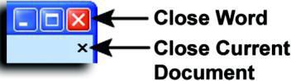

- Selecting Text

Working with Text (Contd.)

Before performing any operation on text such as moving, copying, formatting
etc., the text must be selected. Whenever you select text, it gets highlighted.

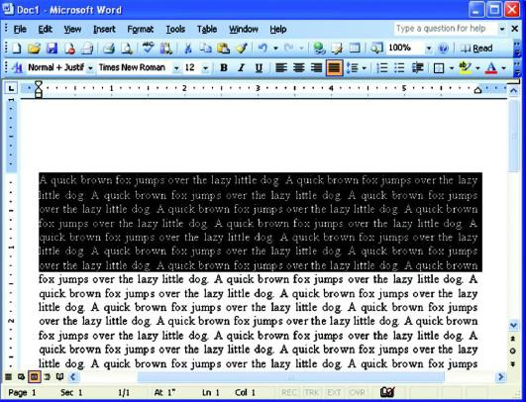

Working with Text (Contd.)

Formatting the Text
As you enter and edit text, you can change its appearance to add emphasis and make the document easier to read. This is known as formatting.

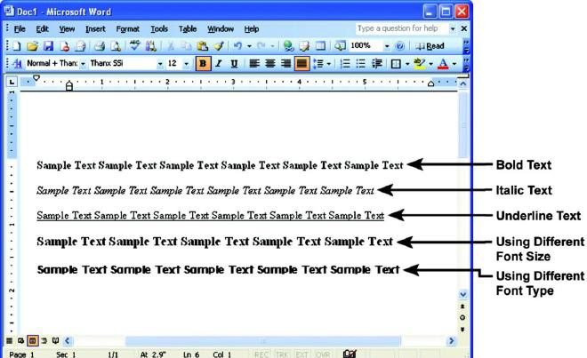

Working with Text (Contd.)
  - Aligning and Indenting Text
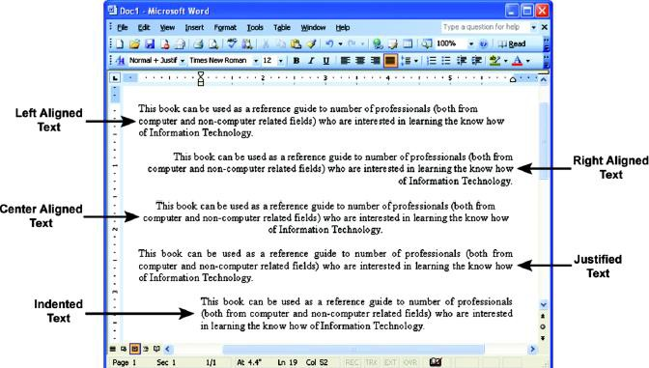
Alignment and indentation operations are a part of paragraph formatting. These operations are performed to give a well-defined “structure” to the document.

Working with Text (Contd.)
  - Formatting Style
A style is a set of formatting specifications that can automatically be applied to the text. Styles can significantly reduce the time it takes to format a document.
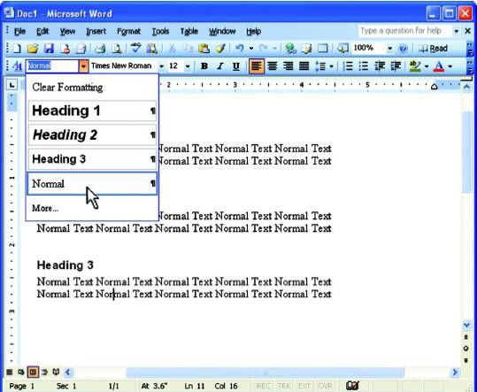

Working with Text (Contd.)

Finding and Replacing Text
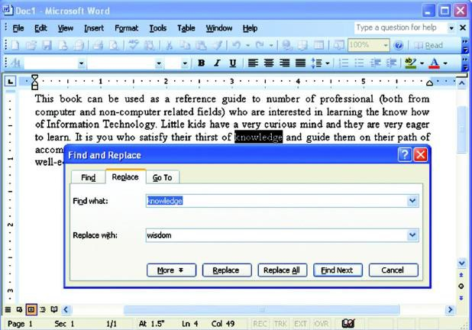
Find and replace option in Microsoft Word is used to locate a particular word, phrase, or set of characters in a document, and replace it with something else.

Working with Text (Contd.)
    - Bullets and Numbering
Microsoft Word supports list-makers with its bullets and numbering features. To use bullets and numbering, first select the text you want to format. Next, use the Bullets ( ) or Numb ng ( ) button on e Formatting toolbar to apply bullets or numbering.
th
eri

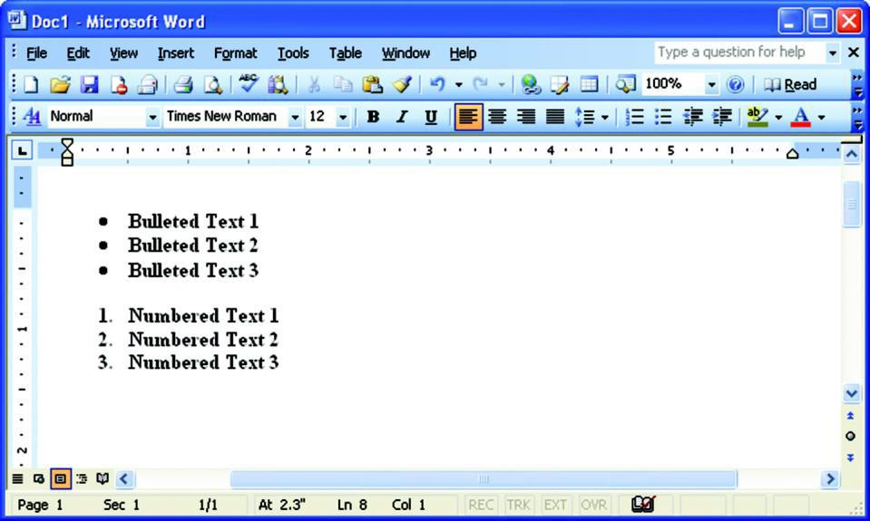
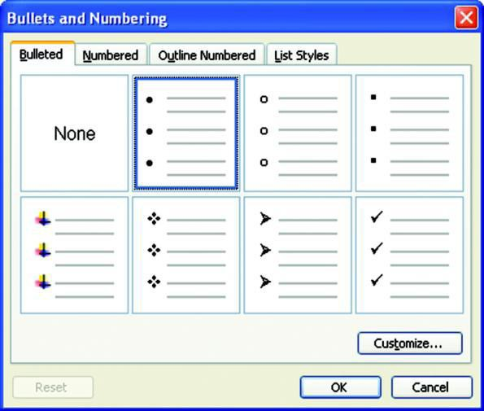

Working with Text (Contd.)
      - Header and Footer
Headers are text that appears at the top of every page, and footers contain text that appears at the bottom of each page. Every Word document contains header and footer areas where you can put a document title, author name, page number, graphics, and any other essentials that you want to repeat over several (or all) pages in the document.

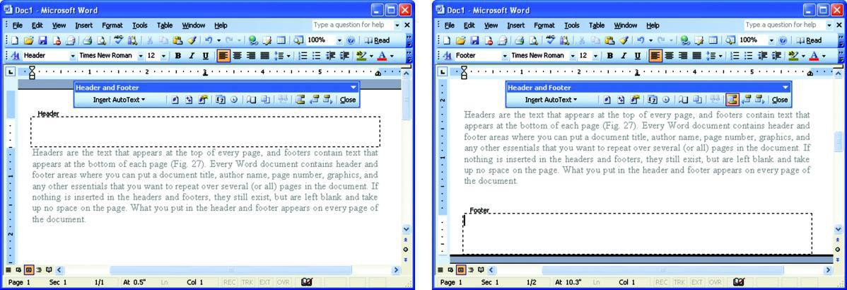

Working with Tables

    - Tables provide a means of presenting information in an organized and attractive manner that displays text in a grid of rows and columns of cells.
    - In Microsoft Word , tables can be created in number of ways:

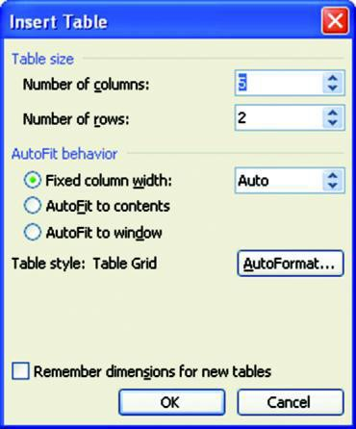
- Select Insert from the Table menu and then choose Table from the pop-up menu to display the Insert Table dialog box, from where you can choose the number of columns and rows required in the document.

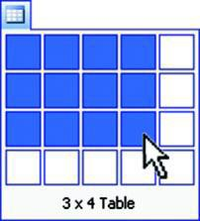
  - Another way of creating a table is to click the Insert Table button ) on the Standard toolbar. Drag the mouse along the grid, highlighting the number of rows and columns for the table.
(

Working with Tables (Contd.)

Tables and Borders Toolbar
It allows you to add border styles, shading, text effects, alignment, and more options to the table.
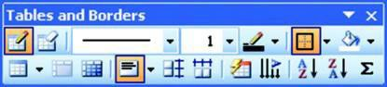

Selecting Parts of a Table
Different parts of a table can be selected either by using mouse or by using the Table menu. For example, for selecting a row, Position the cursor in the row. Click the Table menu, point to Select and then click Row.

Working with Tables (Contd.)

Table Properties
The Table Properties dialog box is used to modify the alignment of the table with the body text and the text within the table. It contains four different tabs:
  - Table: Used to format size, align text, etc.
  - Row: Used to change cell’s alignment and height.
  - Column: Used to format columns.
  - Cell: Used to modify cell.

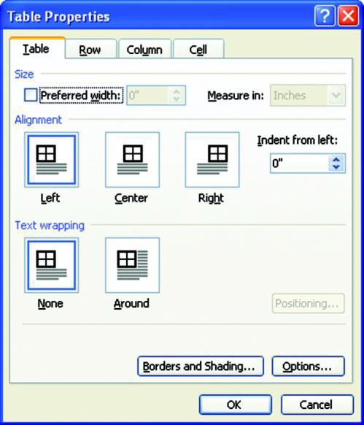
- Moving and Resizing Table
When you place the mouse over the table, a move handle and a resize handle will appear on the top-left and bottom-right corners of the table respectively. Click and drag the move handle to move the table and release the mouse button when the table is positioned where you want it.

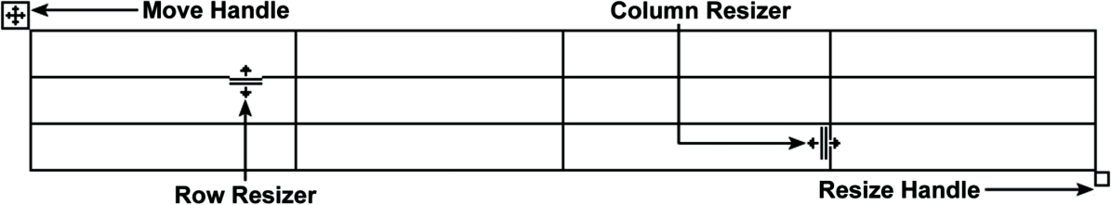

Working with Tables (Contd.)

Formatting text in table
Text stored in table cells can also be formatted using Formatting tool bar. All the usual formatting options such as text alignment, bullets and numbering, spacing, font colors, font styles, etc., work well within tables and cells.
    - Using Table Auto Format: Microsoft Word provides Table AutoFormat feature that allows to apply different formats such as borders, shading, special fonts and color, etc., to a table in a quick and easy manner.

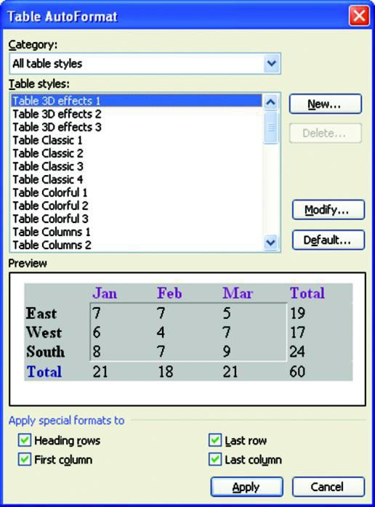

Working with Tables (Contd.)

  - Adding and Deleting Rows and Columns
You can insert rows by using the Table menu.
    - On the Table menu, point to Insert and then choose Rows Above or Rows Below. Similarly, columns can be added by selecting the Columns to the Left or Columns to the Right.
    - For deleting rows and columns from the table, click inside the row or column that you wish to delete or select several rows or columns to delete. On the Table menu, point to Delete, and then click Rows or Columns.
  - Converting Text to Table
You can convert any text whether it is a tabbed list or a series of paragraphs, into a table using the Convert Text to Table feature of the Word.
  - Converting Table to Text
You can also convert an existing table to text using the Convert Table to Text feature of the
Word.

Checking Spelling and Grammar

Using the Auto Spell and Auto Grammar Features
Microsoft Word automatically checks the spelling and grammar as you type the text and provides visual clues about the spelling and grammar unless this feature is turned off. Misspelled words are underlined in red, while sentences with grammatical flaws are underlined in green.

Using Spelling and Grammar Dialog Box
To start the spell check process, perform any of the following steps:
  - Click the Spelling and Grammar button ( ) on the Standard toolbar.
  - Select Spelling and Grammar from the Tools menu.

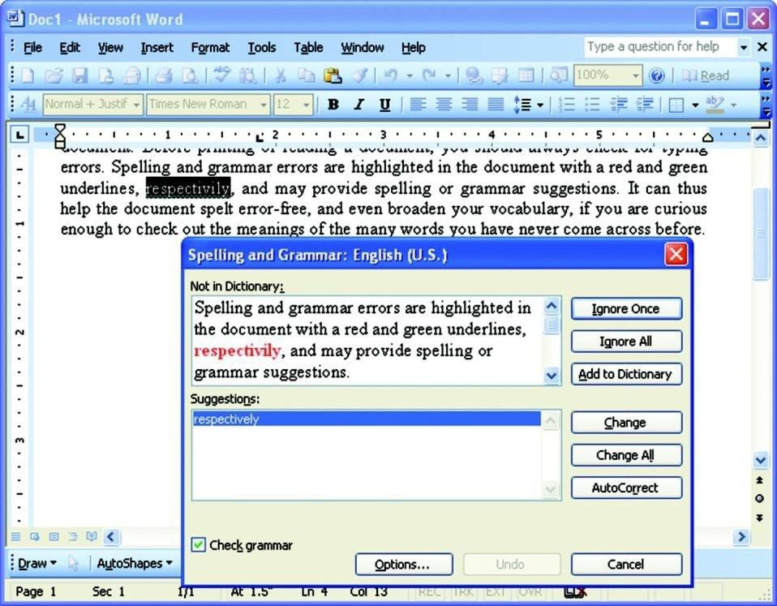

Checking Spelling and Grammar (Contd.)

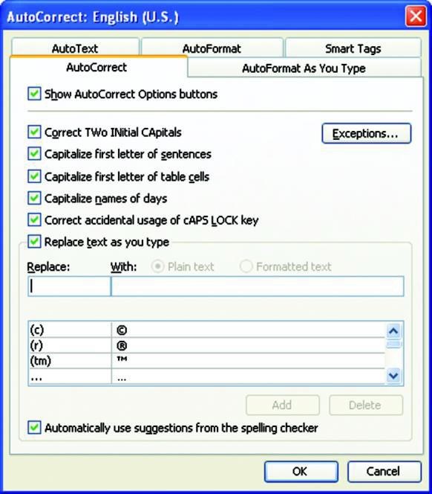
Using AutoCorrect Options
The AutoCorrect Options feature automatically detects common errors like misspelled words, grammatical errors, and incorrect capitalization, and replaces them with the correct text. For example, “grammer” can be rectified as “grammar”.

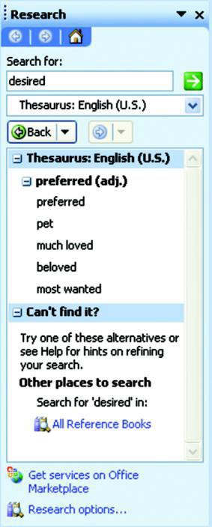
Using Synonyms and Thesaurus
Sometimes you may wish to replace a word with its synonym. Microsoft Word has the Thesaurus feature, which does just the same.

Adding Graphics to Document

Pictures
Pictures are used in the document to enhance its readability and understandability. Some common formats are .BMP, .GIF, .JPG, and
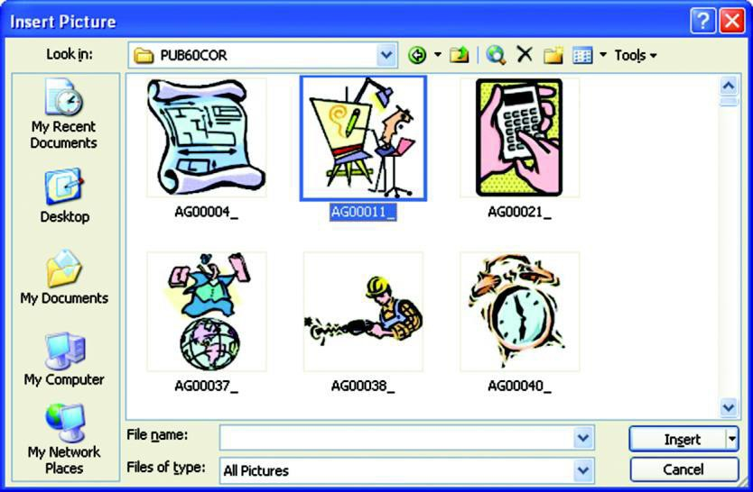
.WMF. Pictures can be inserted in two ways:

- Inserting Picture from a File: Word allows you to insert pictures or scanned photographs from other programs and locations into the Word document.

  - Clip Art: Microsoft Word comes with its own set of pictures in the Clip Gallery. The Clip Gallery includes a wide variety of clip art that makes it easy for you to enhance your documents with professionally designed images.

Adding Graphics to Document (Contd.)

Drawing Objects
Word allows you to add objects such as lines, curves, and WordArt.
The drawing objects include:
  - AutoShapes: Microsoft Word comes with a set of ready-made AutoShapes containing several categories of shapes, including lines, basic shapes, flowchart elements, etc., that you can use in your documents. You can resize, rotate, flip, color, and combine the shapes with other shapes such as circles and squares to make shapes that are more complex. The table shown lists all the available buttons on the AutoShapes menu.

  - WordArt: Using WordArt Gallery, you can create many text effects. You can create shadowed, skewed, rotated, and stretched text, as well as text that can be fitted to pre-defined shapes.

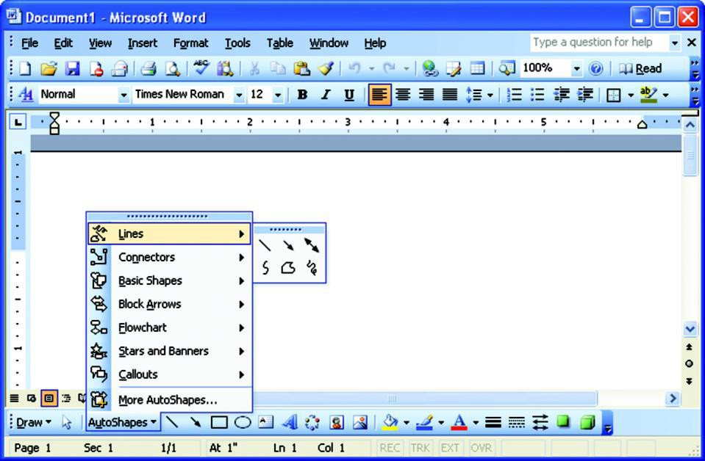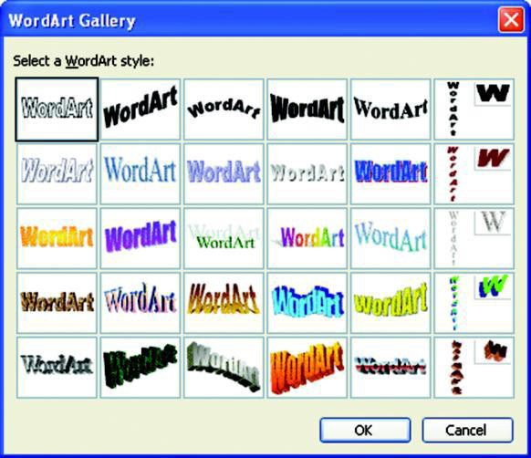

Mail Merge

Components of Mail Merge
    - Mail merge feature of Word allows you to merge generic information which is to be repeated in each letter, mailing label, or envelope, etc., with varying information like, a list of names and addresses of employees. The components of the mail merge are:

      - Main Document: It comprises the generic information in the form of text and graphics. The five types of documents are Letters, E-mail messages, Envelopes, Labels, and Directory.

      - Data Source: It comprises varying information in which records representing individual items are stored. Each record consists of fields, for example, a record of an employee may consist of name and address, where name may consist of fields, FirstName and LastName and the address may contain fields HouseNo, City, and State.

      - Merged Document: It comprises the combination of generic text and variable information. When the information in the data source is merged with the main document, the merge fields are replaced with the variable information representing the data for each individual.
      - For steps of Mail Merge refer Mail Merge PDF

Printing a Document

Setting Page Margins
- Page margins determine the distance between the text and the edge of the paper.
- To specify the margins in the document, choose Page Setup from the File menu to display the Page Setup dialog box.
- Microsoft Word ’s default margins are 1.25 inches on the left and right and 1 inch on the top and bottom.
- To change the orientation (whether to print the document in landscape or portrait mode), select the option from the Orientation section.
- To print on both sides of the page, select the Mirror margins option from the
Multiple pages drop-down list under Pages section.
- To change the size of the paper, click the Paper tab and select the desired size (letter, A4, etc.) from the Paper size list.

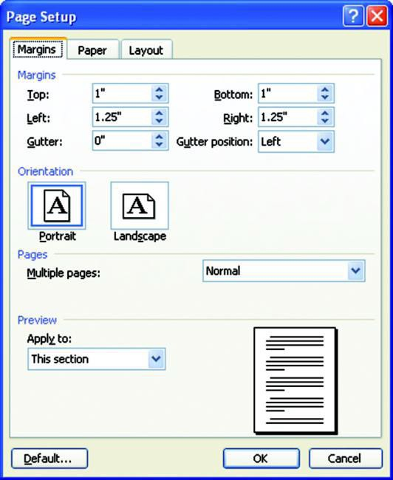

Printing a Document (Contd.)

Print Preview
- Print preview is a way to view the appearance of the printed document onscreen before printing the final output.
- It is a great way to catch formatting errors, such as incorrect margins, overlapped text, boldfaced text, and other text enhancements.
- To view document in print preview mode, choose Print Preview from File menu or click the Print Preview button ( ) on the Standard toolbar.
- To magnify the text for a larger view, click the Magnifier button ) and place the cursor over the text you wish to enlarge. A + sign ( is used to zoom in the text and – sign ( is used to reduce the text size.
(
)
)

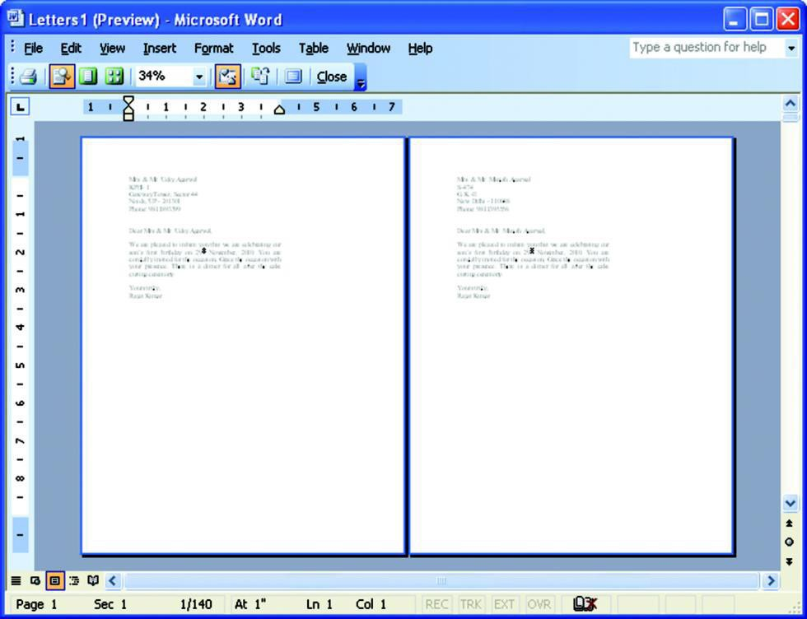

Printing A Document (Contd.)

Printing the Document
  - To print a document, click the Print button ( ) on the Standard toolbar, or select Print from the File menu to display the Print dialog box.
  - This dialog box allows you to select the number of copies and how many pages of the document you want to print. You can also specify the range of the document to print.

